**University name:** Lawrence Technological University

**Department name: ­-**

**Course title:** MCS 1142

**Assignment title:** A STRUCTURED PROGRAM

**Student name:** Hezam Almutairi

**Date:** 02 Oct 2022

**Input data:** This program ask user to input two unsigned integers.

**Detailed instruction on how the program can be compiled and executed**

1. Open MS VS.
2. Then open the project (Almutairi-H-PA03).
3. Then click on build and run button.

**Data flow chart:**

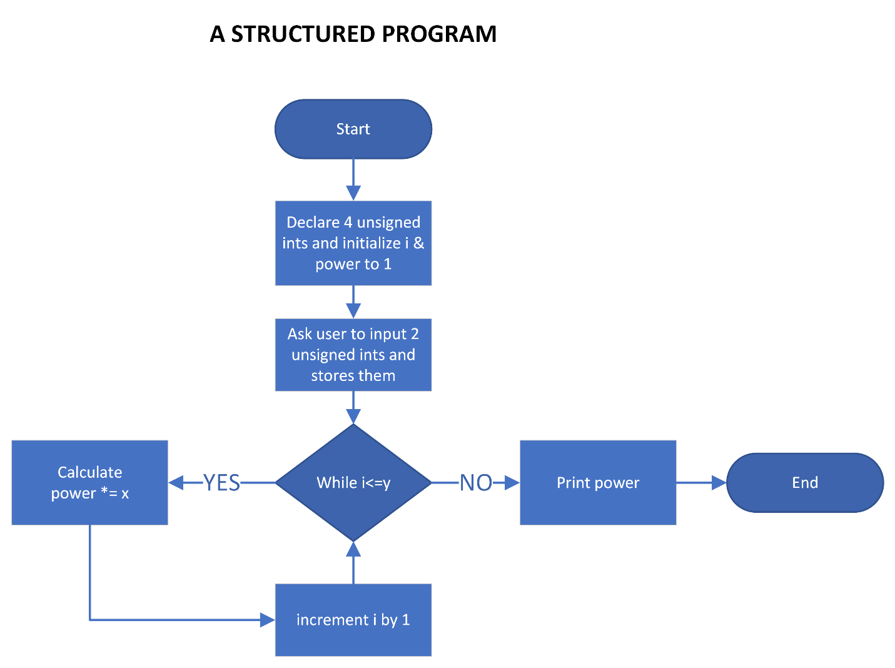

**Output:**

